**Antique Gold Ornate Leaf Small Mirror**

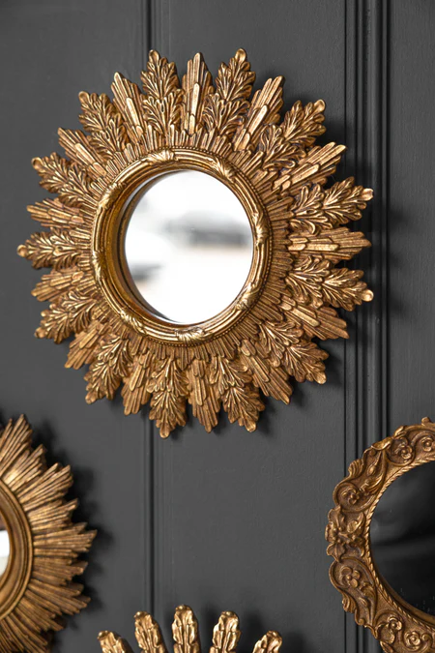The Antique Gold Ornate Leaf Small Mirror is a beautifully crafted piece that combines nature-inspired design with vintage elegance. Its intricate leaf motifs are delicately sculpted around the mirror’s edges, creating a sense of organic beauty and refinement. The antique gold finish enhances its timeless appeal, adding warmth and sophistication to any space. This small-sized mirror is perfect for adding a touch of luxury to smaller areas like entryways, powder rooms, or as part of a gallery wall. Its ornate frame and classic design make it a versatile and charming accent, seamlessly blending with both traditional and contemporary interiors.

+++++++++++++++++